**Technical Documentation – Deploy_Member_Copy**

1. Workflow – Deploys and Executes Member Copy sql artifacts to an Environment (Oracle Database).

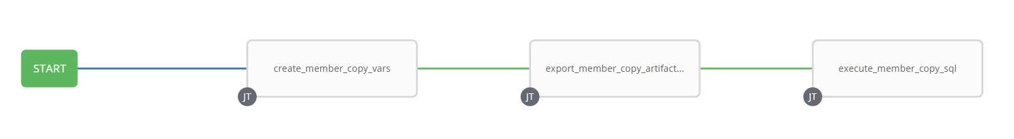

1. Survey – User Supplied Variables

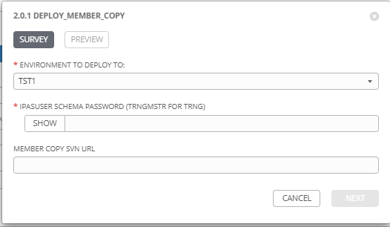

|  |  |  |  |
| --- | --- | --- | --- |
| **Survey Extra Variables** | **Prompt** | **Type** | **Description and Usage** |
| ENV | Environment to Deploy To | Multiple Choice Single Pick | Environment to execute the sql scripts against (DEVL, DEV3, RDEV, TST1, TST2, TST3, TRNG, MUAT) |
| SchemaPassword | IPASUSER Schema Password (trngmstr for TRNG) | Password | Password for the IPASUSER Schema in the environment (TRNGMSTR schema is used against TRNG) |
| MemberCopyArtifacts | Member Copy SVN URL | Text | The SVN URL for the folder containing the member copy sql artifacts. |

1. Jobs Used by the workflow - http://owl.penc.local:18080/svn/deploy_automation/trunk/Ansible_PlayBooks/Harness

| **Job Template** | **Ansible Playbook** | **Project** | **Description and Usage** |
| --- | --- | --- | --- |
| create_member_copy_vars | create_member_copy_vars.yml | Harness | DeploymentLogDir: /codemove_common/dp_automation/refreshes/member_copy  Schema: IPASUSER  StageDir: /codemove_common/dp_automation/stage/member_copy  date_time: '20200908_1026'  stage_server: diagoras1bcp  tower_hostname: pdeploy1bcp.penc.local |
| export_member_copy_artifacts | stage_files_rms_ansible.yml | Harness | Creates the {{DeploymentLogDir}}/{{date_time}}  If the MemberCopyArtifacts is populated, creates the staging directory {{StageDir}}/{{date_time}}, exports the folder specified in the SVN URL and then points the {{StageDir}}/Latest symbolic link to the {{StageDir}}/{{date_time}}.  Creates the Staging Report {{DeploymentLogDir}}/{{date_time}}/Member_Copy_Staged_Files.html |
| execute_member_copy_sql | execute_member_copy.yml | Harness | Executes the member copy sql files as IPASUSER schema (TRNMSTR for TRNG) in the follogin order   1. insert_member_copy_tables.sql 2. copy_sin.sql   If any errors are generated by the sql executed the job completes, it only fails if one or more of the sql files do NOT exist. The output needs to be reviewed to ensure the sql files executed properly.  C:\Users\mikcharc\AppData\Local\Temp\SNAGHTML662ea06.PNG |